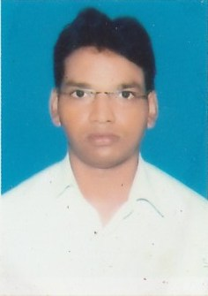  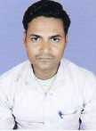  Sunny Kumar  (9570143390  (7481970825  Email:  Skyadav2809@gmail.com  Present Address  S/O-Rajesh Prasad Yadav West Lane Of C P I Office Kazipur Nayatola Patna 800004  Permanent Address  S/O-Rajesh Prasad Yadav West Lane Of C P I Office Kazipur Nayatola Patna 800004 | Resume  SUNNY KUMAR  Vision  - A career that is enriching in terms of inputs which provides ample scope for employing my abilities to achieve constant advancements and to work for the betterment of the organization.  Objective  - Intend to build a career with leading corporate of Hi- Tech environment with committed and dedicated people, which will help me to explore myself fully and realize my potential and contribute my best to the organization.  System Proficiency  - DCA  Educational qualification  - Passed B.Com from P U in 2012  - I.Com from BSEB Patna with 60.10% in 2008  - 10th from BSEB Patna passed with 46.00% in 2006  Personal Details  Name : Sunny Kumar  Father’s Name : Rajesh Prasad Yadav  Date of Birth : 29/09/1991  Nationality : Indian  Sex : Male  Marital status : Single  Languages known : English,Hindi  DECLARATION  I hereby declare that the above mentioned information is genuine to my knowledge and I bear the responsibility for the correctness of the above mentioned particulars.  Place: Signature  Date: Sunny Kumar  Professional qualification  MBA (Master of business administrative) in Marketing  I completed my MBA of 2009- 2011 in the month of September with first class distinction

